**Validating Input Assessment**

**Validating** is the process of checking to make sure that data that is entered is of the correct type or range. There are a number of ways of doing this but all rely upon a loop to allow the user to reenter a value if it does not meet certain criteria. E.g. an appropriate choice from a menu.

## Using a loop

**Task 1:** Write a program that asks the user to enter a number between 1 and 5. Use a loop to validate the integer value that they enter.

**Evidence:**

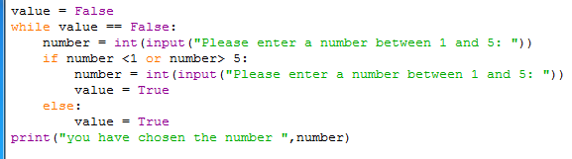

## Using try/except

Entering an incorrect data type (e.g. a string when an integer is expected) causes an *exception* error. Using the try:/except method can ‘catch’ this exception error without the code crashing.

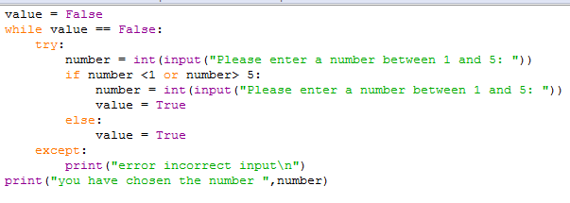**Task 2:** Amend the above code to include a try:/except: validation to catch non integer values being entered.

**Evidence:**

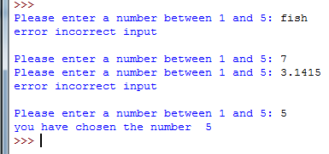

## Using a list

Validation can also be achieved by using lists. If a list contains acceptable entries then the selection statement can be used:

If <variable> not in [mylist]:

Entry not valid

**Task 3:** Assume a list animals=[“Pig”, “Cow”, “Sheep”, “Horse”, “Chicken”, “Goat”, “Goose”, “Duck”, Dog”, “Cat”] Write a program that asks the user to enter an animal found on a farm. Validate their entry using the list. Output an appropriate message.

**Task 4:** Amend task 3 so that the code works regardless of whether upper case is used or not.

**Evidence:**

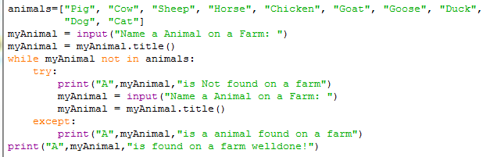

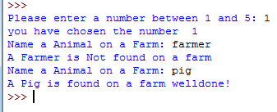

## Data Types and condition statements

Any condition can be used to validate data entry. If a number is entered as part of a string (for example as part of a postcode) the method isdigit() returns True if the string is a number. e.g. Assume a variable entry is assigned a value of “4” then entry.isdigit() returns True

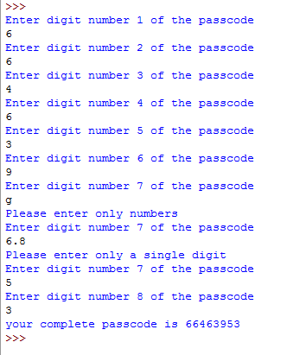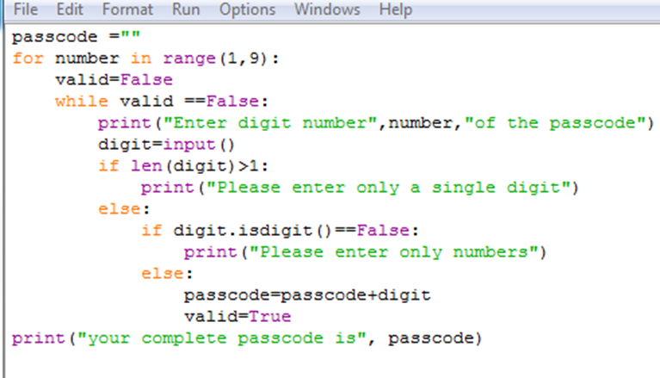**Task 5:** A security system uses a passcode that contains 8 numbers stored as a single string (it is possible for the first character to be zero). Write a program that will accept individual entries for each of the 8 numbers in the passcode. The program must validate each number entered to ensure that it is a digit and only one character. The program should print the complete passcode as a single string.

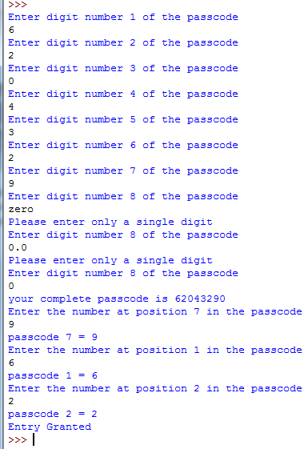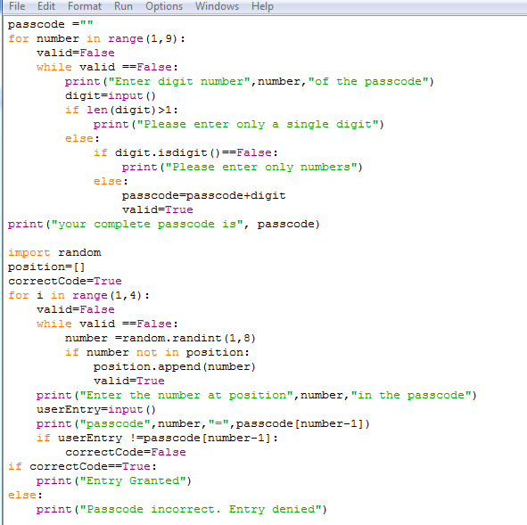**Task 6:** Use the passcode from task 5. Write a program that randomly select 3 numbers from the passcode at three different positions. The user should enter the numbers at each position. The program should give appropriate messages.